Abstract 88782
Title : | Acute coronary syndrome with ST-segment elevation (STEMI): "lives saved" before hospital
Topic : | 04.13 - CPR (Cardiopulmonary resuscitation)
Category : | Bedside
Option : | No Options
On Behalf : e-MUST Study Group

F. Lapostolle¹, X. Mouranche², N. Karam³, S. Bataille³, JY. Letarnec⁴, GA. Capitani⁵, S. Cahun-Giraud⁶, T. Boche⁷, H. Lefort⁸, Y. Lambert⁹ - (1) AP-HP - Hospital Avicenne, EMS Department, SAMU 93, Bobigny, France (2) Ile de France Health Regional Agency (ARSIF), Paris, France (3) AP-HP - European Hospital Georges Pompidou, Department of Coronary Disease, Paris, France (4) Melun Hospital, SAMU 77, Melun, France (5) Hospital Sud Francilien, SAMU 91, Corbeil-Essonnes, France (6) AP-HP - Hospital Raymond Poincare, Garches, France (7) AP-HP - University Hospital Henri Mondor, Creteil, France (8) Brigade des Sapeurs Pompiers de Paris, Emergency Department, paris, France (9) Versailles Hoapital, SAMU 78, Versailles, France
Purpose: STEMI may be complicated by cardiac arrest (CA) often by ventricular fibrillation. The risk of AC justified the creation of the Cardiologic Intensive Care Units few decades ago. The impact of the French pre-hospital medical management of patients suffering from STEMI on AC outcome remains unknown. Our objective is to study outcome of victims of AC among patients managed by a physician in pre-hospital setting (by SAMU Mobile Intensive Care Unit) for STEMI.
Methods: Data are obtained from the prospective registry that lists all STEMI managed by eight SAMU of Paris area (11 millions inhabitants). Patients requiring cardiopulmonary resuscitation were specifically studied. Primary endpoint, "lives saved", was defined as prehospital and hospital survival. Quantitative variables were studied on average (confidence interval) and qualitative variables were studied in percent (confidence interval).
Results: From 2002 to 2011, 16.346 STEMI managed by French SAMU emergency physician in prehospital settings were included in the registry. 959 (6%) AC complicating STEMI were reported. 760 (79%) occurred in men. The overall average age was 59 years (58-60). Survival to hospital arrival was 90% (88-92). Discharge survival rate was 63% (60-66). The evolution of survival regarding time is reported in the figure 1. Conclusions: Over 90% of patients treated in a pre-hospital for AC complicating STEMI arrived alive at the hospital. Final outcome was high. These results justify, by themselves, an intensive pre-hospital management of patients with suspected ACS.
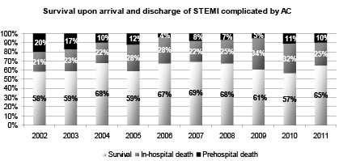
figure 1

